Project Snowflake Report

Optimisation
In this project, Snowflake was used to load, transform, analyse, and share a dataset of restaurant information stored in JSON format. The project involved multiple stages, including setting up a warehouse, loading semi-structured data, transforming it into relational tables, running analytical queries, and visualising the results in Power BI. Throughout the project, optimisation was considered at each stage. In a cloud data warehouse, optimisation is not only about improving query performance but also about reducing cost, improving efficiency, and making the data easier to work with.
One of the first optimisation steps was the configuration of the virtual warehouse. A warehouse named RESTAURANT_PROJECT_WH was created with a size of XSMALL. This was appropriate because the dataset used in the project was relatively small and did not require a large amount of compute power. Choosing a warehouse that is too large would increase credit usage unnecessarily, while choosing one that is too small could slow down queries. In this case, the XSMALL size provided a good balance between performance and cost. The warehouse was also configured with AUTO_SUSPEND = 60 and AUTO_RESUME = TRUE. This means the warehouse automatically stops after one minute of inactivity and restarts when a new query is executed. This is an important optimisation technique because it prevents compute resources from running when they are not needed, helping to reduce overall cost.
Another key optimisation technique was the approach taken to data loading. Instead of immediately transforming the JSON file into a structured format, the data was first loaded into a raw table called RESTAURANT_DATA using a single VARIANT column. This approach is commonly used in Snowflake when dealing with semi-structured data such as JSON. By storing the raw data in its original format, the loading process is simpler and more flexible. It also allows the data to be inspected and reused if needed. This separation between raw data and transformed data makes the system easier to maintain and reduces the risk of errors during ingestion.
The transformation stage also played an important role in optimisation. The raw JSON data contained nested objects and arrays, which are not ideal for analysis. To improve performance, the data was transformed into three relational tables: RESTAURANT, GRADE_TABLE, and CATEGORY. The RESTAURANT table stores the main information about each restaurant, including name, stars, and contact details. The GRADE_TABLE stores individual grade values, and the CATEGORY table stores the different categories for each restaurant. By separating the data into these tables, it becomes much easier to perform joins, filters, and aggregations. This also avoids repeatedly extracting values from the JSON structure in every query, which would be less efficient.
The use of LATERAL FLATTEN() was particularly important in this process. The JSON dataset stores both grades and categories as arrays, which cannot be directly analysed in their original format. LATERAL FLATTEN() was used to convert these arrays into rows when creating the GRADE_TABLE and CATEGORY tables. This step only needs to be done once during transformation, rather than during every query. As a result, the queries in the analysis phase are simpler and faster to execute. This is a good example of how preprocessing data can improve overall performance.
Error handling was also included as part of the optimisation strategy. When loading the data using the COPY INTO command, the option ON_ERROR = CONTINUE was used. This ensures that if some rows contain errors, the rest of the data can still be loaded successfully. This is important in real-world scenarios where data may not always be perfectly clean. Allowing the process to continue improves reliability and avoids having to restart the entire load due to a small number of issues.
Another important optimisation technique used in this project was the creation of a materialized view. The materialized view MV_MAX_GRADE was created to store the highest grade recorded for each restaurant. This means that the aggregation using MAX(GRADE) does not have to be recalculated every time the query is run. Instead, Snowflake stores the result and updates it automatically when the underlying data changes. This significantly improves performance for queries that need this information repeatedly. Materialized views are especially useful in analytical workloads where the same aggregations are used frequently.
The SQL queries used in the analysis phase were also designed with optimisation in mind. By using relational tables instead of the raw JSON data, queries were easier to write and more efficient to execute. A Common Table Expression (CTE) was used to calculate average grades for each restaurant before applying filters. This made the query easier to understand and avoided repeating calculations. In addition, a window function using RANK() was used to identify the top three restaurants in each category based on their star ratings. Window functions allow complex analysis to be performed without needing multiple nested queries, which improves both readability and performance.
Another aspect of optimisation in this project was preparing the data for visualisation. The data used in Power BI was taken from the transformed relational tables rather than the raw JSON table. This reduces the amount of processing required in Power BI and ensures that the data model is clean and consistent. By handling transformations in Snowflake, which is designed for data processing, the performance of the visualisations is improved. It also makes the dashboards easier to maintain, as the logic is centralised in the database rather than spread across the reporting tool.
Data sharing was also implemented efficiently in this project. Instead of exporting and transferring data manually, Snowflake’s secure sharing feature was used to share the database with another Snowflake account. This allows the data to be accessed directly without duplication. From an optimisation perspective, this is beneficial because it reduces storage usage and ensures that all users are working with the same up-to-date data. The share was configured to allow access to the database, schema, tables, and materialized view, making the dataset fully accessible for analysis.
Overall, optimisation was applied throughout the entire project. The warehouse was configured to balance performance and cost, raw data was loaded efficiently using a VARIANT column, and the data was transformed into relational tables to improve query performance. Techniques such as LATERAL FLATTEN(), error handling, materialized views, and efficient query design were all used to improve performance and usability. In addition, preparing the data properly for Power BI and using Snowflake’s data sharing capabilities further improved the efficiency of the solution. These techniques demonstrate how Snowflake can be used effectively as a cloud data warehouse to handle semi-structured data and support analytical workloads.

Visualisation
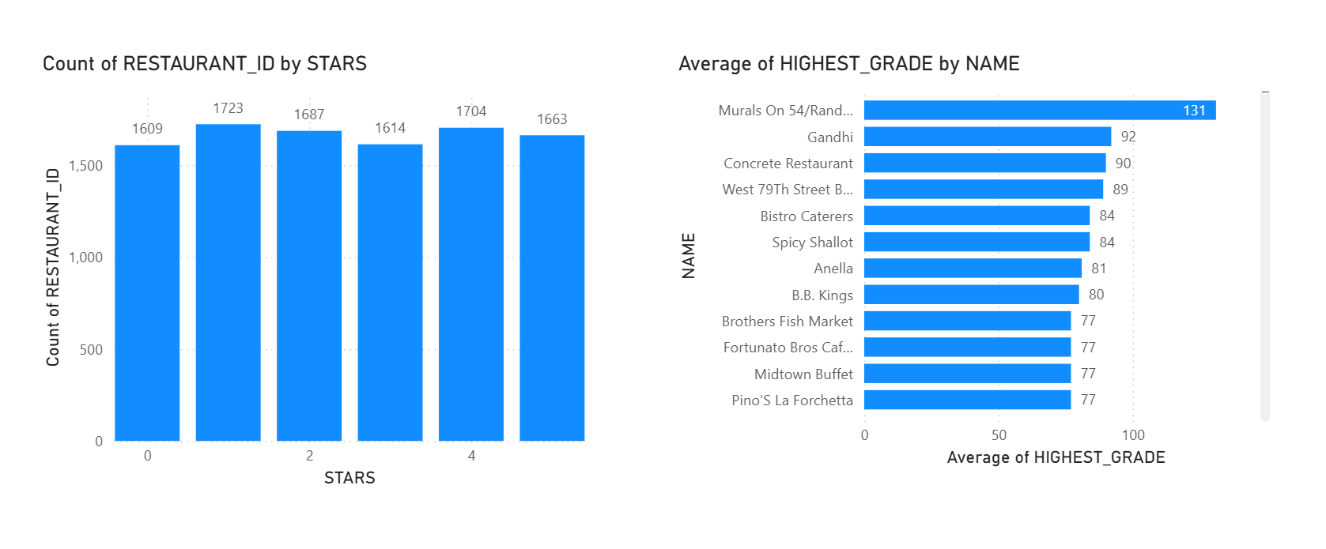
Figure 1 Visualisation
The first visualisation shows how many restaurants fall into each star rating. This gives a quick overview of how ratings are distributed across the dataset. From the chart, it is easy to see whether most restaurants have high ratings or if the ratings are more spread out. This helps give a general idea of overall restaurant performance and customer satisfaction.
The second visualisation shows the top restaurants based on their average grade. This uses data from both the RESTAURANT and GRADE_TABLE tables. Since lower grade values represent better inspection results, restaurants with lower average grades can be considered higher performing. By focusing on the top results, the chart highlights the best-performing restaurants based on inspection data. Together, these two visualisations give a good overall view of both customer ratings and inspection performance, making it easier to understand the dataset from different perspectives.

